zVM 7.3 System Installation Second Level

This document covers the necessary preparation and steps required to install zVM 7.3 to a mainframe LPAR. This method uses an existing first level zVM operating system to hold install files, install the files to DASD and finally IPL from those DASD from within the first level with a privileged user. That makes this an ideal means to tailor a system prior to putting it into production.

Requisite Information Pre) Fill out worksheets.  
DASD Mod : 1) Create container/IPL User for 2nd Level.   
IP Address : 2) FTP Files to zVM.  
Started : 3) Log into the Install User.  
Gateway : 4) Run **INSTPLAN.**  
Subnet Mask : 5) Fill and submit **INSTPLAN** panels.  
System Name : 6) Attach any additional devices and run **INSTALL** on system.  
Filepool Name: 7) Login with Maintenance User.  
HMC Account : 8) Subsequent IPL’s.  
 Post) Start Utility Installs after inspecting new system.

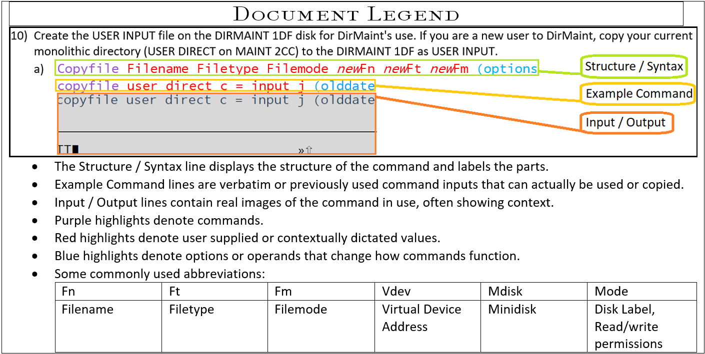

Detailed Instruction:

1. When installing a second level system you must first create a user to contain the installation files. (See User Creation.) You will also need the user to be fitted with:
   1. Access to the INSTPIPE MODULE on your current system. The module was shipped on the MAINT 193 minidisk.
   2. Privilege class G.
   3. Privilege class B, if installation DASD volumes are not already attached to your installation user ID.
   4. At least 128 MB of virtual storage.
   5. An MDISK with 8,000 cylinders of storage available. (ex. Name: 5555)
   6. A 191 read/write minidisk accessed as file mode A.
   7. If installing from a CMS-formatted minidisk (referred to as "From a VM Minidisk"), write access to the minidisk where the files will be loaded.
   8. A 2222 read/write minidisk, matching the supported DASD type (3390 or FBA) of your installation media, that is exactly 10 cylinders (3390.)
   9. A 24CC read/write minidisk, matching the supported DASD type (3390 or FBA) of your installation media, that is exactly 10 cylinders (3390.)
   10. A 2CF0 read/write minidisk, matching the supported DASD type (3390 or FBA) of your installation media, that is exactly 120 cylinders (3390.)
       1. Ex. 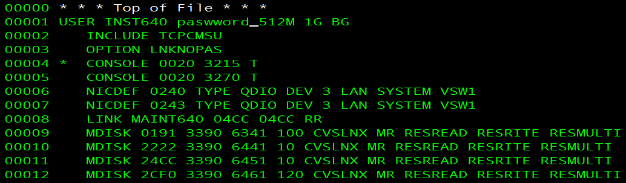

1. FTP the installation files over to the container MDISK for the Install User to access. (See –hyperlink FTPing How To.)
   1. Be sure the files are the correct size and length (part of the FTP instructions sets this.)
   2. Verify the file type is IMAGE rather than $default. If file type is $default use the provided command below to rename the files.
      1. **Rename filename filetype filemode newFN newFT newFM  
         rename * $default w = image =**

1. Log into your privileged Installation User. (Ex. Here is INST640)
   1. Spool the console to make sure it is empty, started, and spooled to the reader.
      1. **spool console close start \***  
         RDR FILE *filenum* SENT FROM
   2. Verify that you have a 2222 read/write minidisk
      1. Q v 2222  
         
   3. Link and Access install user’s 5555 mdisk as filemode w.
      1. Link user mdisk mdisk filemode  
         link xSystemx 5555 5555 wr  
         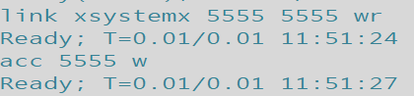
   4. Access the MDISK as W for the upcoming command.
      1. Access mdisk filemode  
         Acc 5555 W  
         
   5. Verify that INSTPIPE MODULE exists in your search order. If it says not found, simply access Maint 193.
      1. Listfile filename filetype filemode  
         Listfile instpipe module *  
         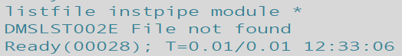
      2. vmlink user mdisk  
         vmlink maint 193  
         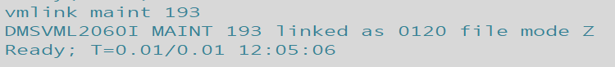
      3. (Desired output shown below)  
         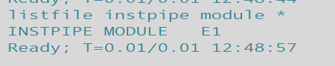
   6. Copy necessary files for DVDPRIME to 2222 MDISK by running INSTPIPE.
      1. INSTPIPE  
         
   7. Decode, unpack, and write the files needed to run DVDPRIME to the 2222 minidisk.
      1. pipe dvddecod *ddd*222 image w |UNPACK| *restcmnd* 2222  
         pipe dvddecod CKD222 image w |UNPACK| ECKDREST 2222  
         
         1. *ddd***CKD** for **3390** or FBA for FBA (SCSI). This value must be entered in uppercase.  
            *restcmnd***ECKDREST** for **3390** or MDREST for FBA (SCSI).
   8. Access install user’s 2222 mdisk as C and Run DVDPRIME.
      1. Access mdisk filemode  
         Access 2222 c  
         
      2. Access mdisk filemode  
         Access 191 a  
         
      3. Dvdprime DASDtype (operand  
         Dvdprime 3390 (disk  
         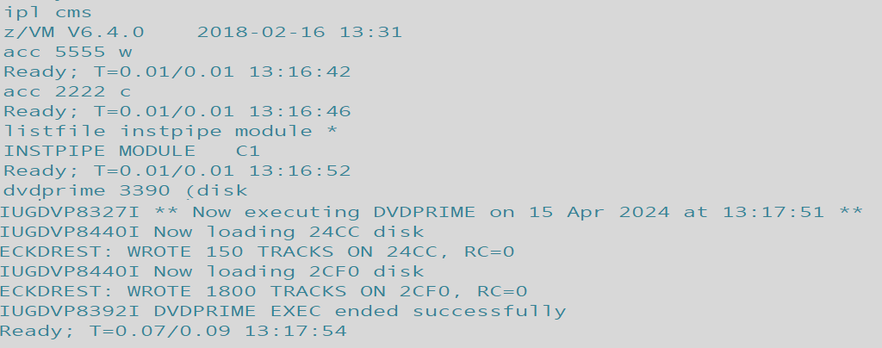

1. Verify access to mdisk 4CC is established (24CC for 2nd Levels) and run, “**Instplan** *traditional”* to begin Installation Wizard and begin filling panels in accordance with Installation Worksheets.
   1. **Query** *device* *filemode***Q** *disk C*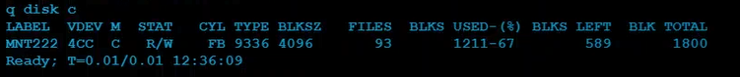
   2. **Instplan** operand**instplan** traditional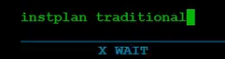(Installation Wizard Panels will open)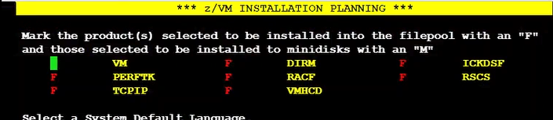

1. Fillpanels with information established and recorded on Installation Worksheets.  
     
   
   1. Place X’s on spaces to make selections, Function keys to receive help, quit or submit.
      1. Note: Very important to take note of any values input that aren’t present on Worksheets for posterity.  
         Ex. Did you load DIRM onto a Minidisk (M) or SFS File System (F)? Different password, new name, etc.
      2. For Format selection choose No if volumes are already CP formatted. Selecting no will still Label the volumes. ‘N’ was chosen in this example.
   2. Answer **Y** when asked whether to continue after selection of Cluster name and submission. Which will reopen the Installation Wizard.  
      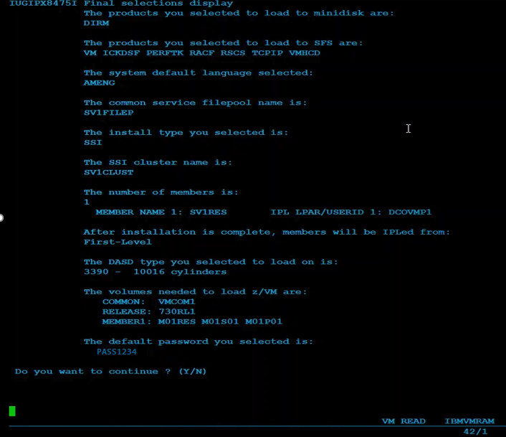
   3. Fill in the new Panels and Submit (F5)
   4. The SSI Cluster is then IPLed. Confirm the output messages match what you have marked down for your Installation Worksheets.  
      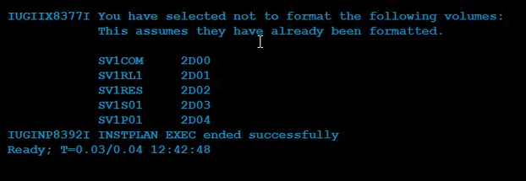

1. Attach any unattached volumes (DASD) used/listed on your installation worksheets that are not already attached and run **INSTALL** to install the newly loaded and specified system.
   1. **Query** operand**q dasd**(None of the DASD used in the Install are attached yet as shown above.)
   2. **Attach** *dasdaddr target***Att** *2d00-2d04* *  
      
   3. **Install**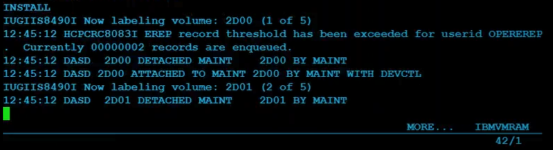(A large number of messages will scroll past the screen as shown below.)  
      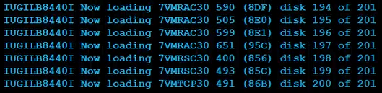
   4. After the two maint disks Load; system will establish values, create connections, attach devices, and generate files etc. - navigate the message scrolling with the Clear key. The system will shut down and REIPL, beginning more setup tasks, finally asking the user to **press** <*ENTER*>.

1. **Press** <*ENTER*> key to continue from system IPL/Load output messages and Login-Screen then log in with MAINTvrm
   * 1. (Maintvrm = Maint version release modification = maintenance user + zVM version 7.3 = MAINT730)
   1. **Press** *<ENTER>* key  
      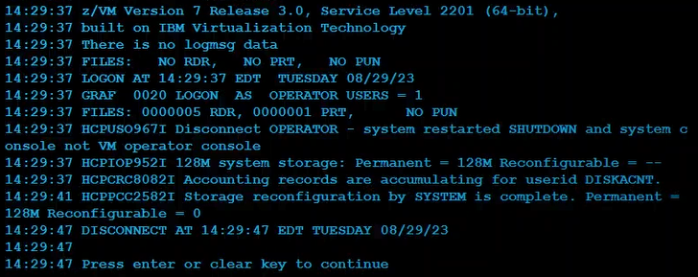
      1. If logged in as Operator (MAY be auto-disconnected to the login screen, if not :) use the disconnect command and log into MAINTvrm.  
         #cp disconnect  
         #cp disc
   2. **Log** **in**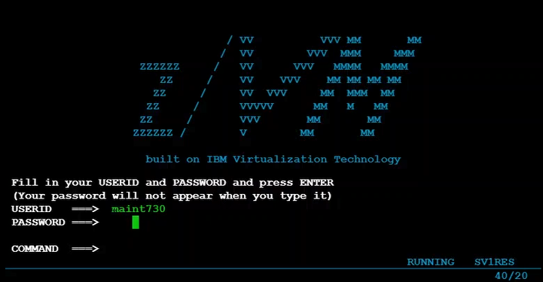

1. In order to IPL the system again beyond the IPL at System installation, from the first level host system submit an IPL command from the user that will host the 2nd level system.
   1. Ex.  
      IPL vdev  
      IPL 705D
      1. TCPIP will need to be installed before running remotely from a disconnected user.
         1. After installing TCPIP to IPL a second level system submit xautolog and FOR commands from another privileged user.
            1. Xautolog install-user  
               Xautolog inst640
            2. FOR user CMD command operand  
               For inst640 cmd set run on
            3. FOR user CMD command operand  
               For inst640 cmd term conmode 3270
            4. For user CMD command operand  
               For user CMD IPL 705D

(a), (b), (c), (d) together subsequently will log the user on, set its running parameters for hosting the system, then IPL the system via the RES volume on the specified DASD.

Return to Overview of System Installation Second Level (top)

*Return to System Installation Second Level Method*  
**User Creation**:

Creating a New User



1. Request a copy of the disk map to identify GAP’s in available storage via :
   1. Dirm Dirmap  
        
      
   2. Obtain the Directory map file via :
      1. Receive spoolid (rep  
         Receive 41 (replace  
         
         1. Rep option replaces any current same name file
   3. Identify the region used for user storage (typically rows of Name 191) and find a gap of 100 or more taking note of the cylinder the starts the gap:  
      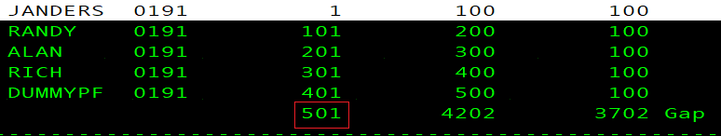
      1. The gap-start cylinder will be the number used to edit the MDISK statement for the new user’s (In this example the gap begins on 501)
2. Acquire copy of USER Direct CMS file to act as template.
   1. Dirm for user get  
      
      1. Should the file be locked already submit an unlock then repeat step 2)a)  
         Dirm for user unlock  
         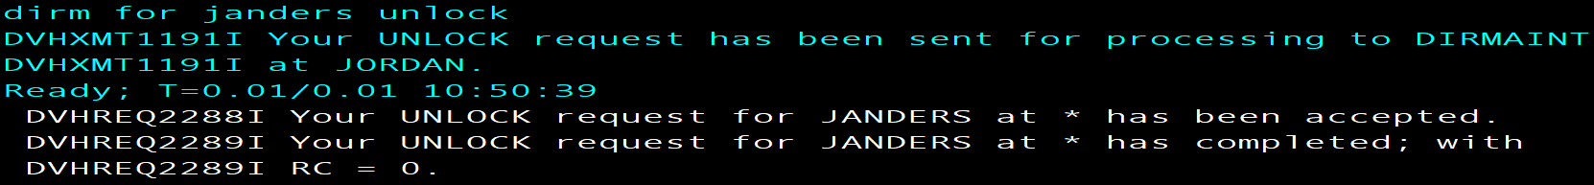
   2. Obtain the Direct file via :
      1. Receive spoolid (rep  
         
         1. Rep option replaces any current same name file
3. Xedit the Direct file to match the new user’s desired login, storage, and access information
   1. Xedit fn ft fm  
      xedit dummypf direct a  
        
      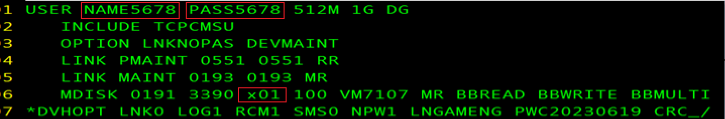
      * 1. Edit username and password
        2. Include TCPCMSU (this profile contains shared links and basic console statements)
        3. Nopass Option for utility drives (ex. MAINT/DEVMAINT/PMAINT)
        4. Link and MDISK statements to access tools and your personal storage (191 A)
           1. Be sure to write the correct starting cylinder((x01 in red box above) Step 1-c’s image shows the example gap in red box)
        5. POSIXINFO UID and GID if intended to use BFS
   2. Type FILE in the command line to save the file.
4. Put on Judas Priest's Screaming For Vengeance.
   1. Turn it up to 11.  
      
5. Request, acquire and update the authfor control file. (This enables commands, do so only for known admins.)
   1. Dirm send authfor control  
      
      1. Add copies of the 150 and 140A lines for User – Matching others in file
   2. Receive spoolid option  
      Receive 105 (replace  
      
   3. Dirm file authfor control  
      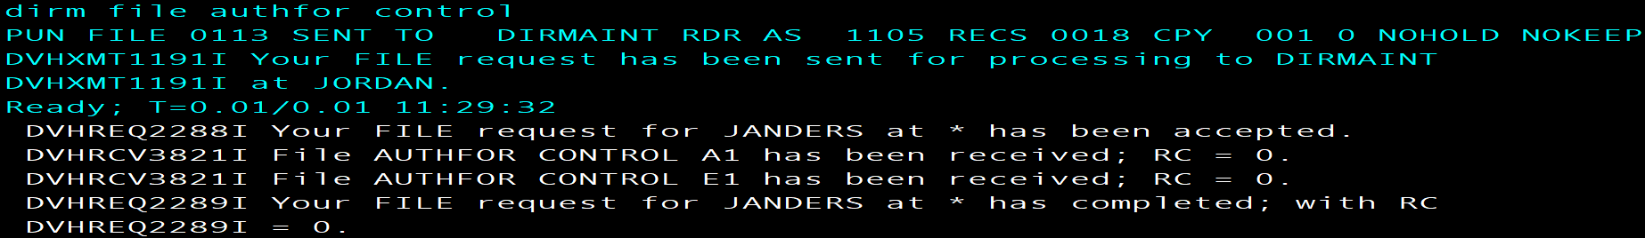
      1. This submits changes made to the Authfor file
6. Add the user’s name to the system :
   1. Dirm add user  
      DIRM add Rich  
      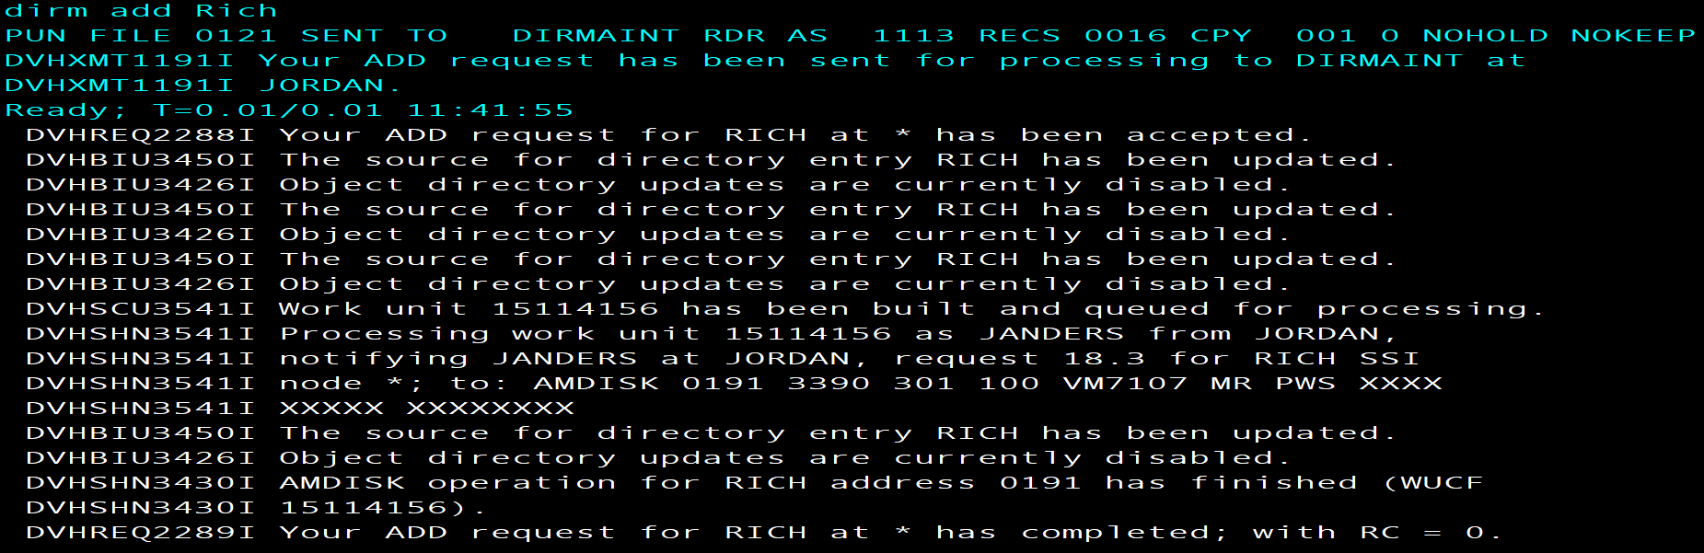
7. Check the newest USER MDISKMAP to make sure there are no Overlaps.
   1. Use the slash character and user name to Xedit search the DISKMAP:
      1. /username
8. Logon to the new user and FORMAT 191 A
   1. FORMAT vdev filemode  
      FORMAT 191 A  
      
      1. Answer 1 for Yes  
         
      2. Give minidisk unique name (typically three letters three numbers)  
         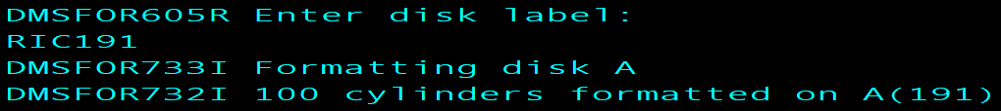
9. VMLINK to another user to get the needed setup/reference files:
   1. Vmlink user 191  
      VMLINK Rich 191  
      
      1. profile exec
      2. syn synonym
      3. profile xedit  
         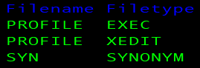
   2. Acquire the files using copyfile or sendfile them from another user to new user
      1. Copyfile fn ft fm Newfn Newft Newfm  
           
         or
      2. Sendfile fn ft fm to user
   3. Pull down the copies
      1. Receive spoolid (options  
         
10. If any additional changes were made after, “DIRM add name” (step 6-a) send the new Direct file to DIRMAINT (Or update the directory/bring changes online)
    1. DIRM for user options  
       Dirm for Janders replace   
       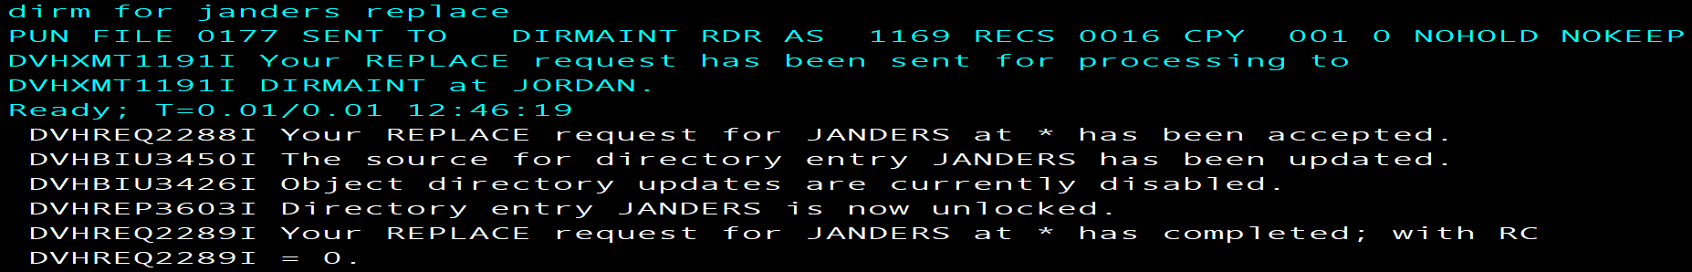
       1. If the file is unlocked and requires a lock for replacement input the following and repeat 10-a.
          1. Dirm for user options  
             DIRM for Janders lock  
             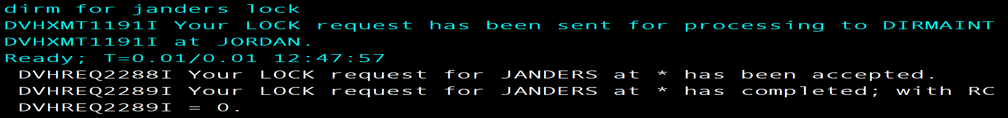  
             Return to Step1 of System Installation Second Level Method

***Return to System Installation Second Level Method*FTP Method**

**Using a z/VM FTP server to receive and load files to a z/VM minidisk (zVM 7.3 Installation Guide.pdf, Appendix K.)**

The following procedure will receive and load the z/VM product DVDs or electronic envelopes to a minidisk on your z/VM system. If loading the files from the electronic envelopes to a directory on your workstation, make a note of the directory path name. Make sure the minidisk where you will load the files is not attached in write mode by any user ID on z/VM. You must have an FTP server running on the z/VM system and a user ID on z/VM that owns an 8000- cylinder minidisk. The minidisk should be formatted with 4K blocks. The user ID should be logged off while you are loading the installation files. To begin open a DOS window on your work station (Like CMD Command Prompt).

**Note**: For this example, the user ID used was JORDAN and the minidisk is 191 and the files were stored on a windows desktop folder named zPROTempBox.  
  
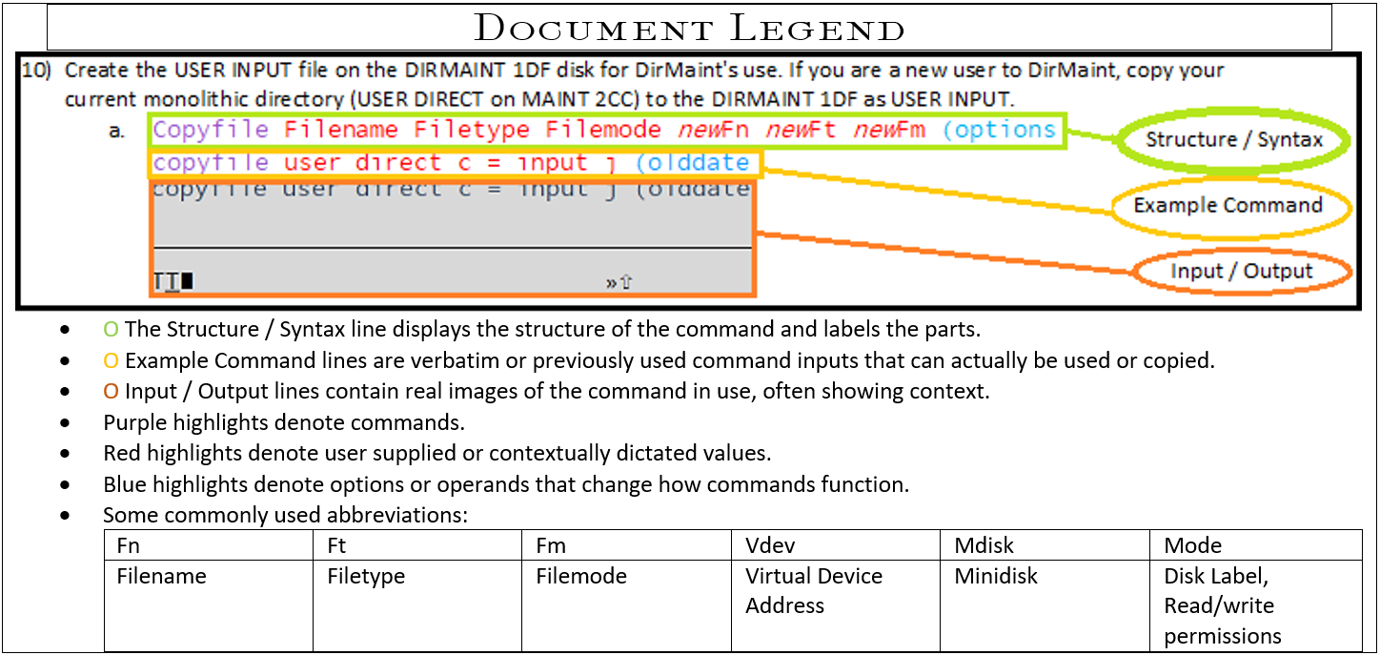

1. Start the FTP session with your z/VM host replacing the x placeholder with the appropriate IP:
   1. ftp *options ipaddress*  
      ftp -i *xx.x.xx.xxx*  
      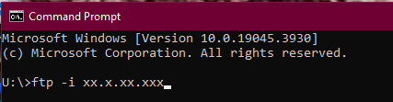
2. Enter the z/VM user ID that can access the minidisk in write mode and the password for that ID:
   1. Username  
      JORDAN  
      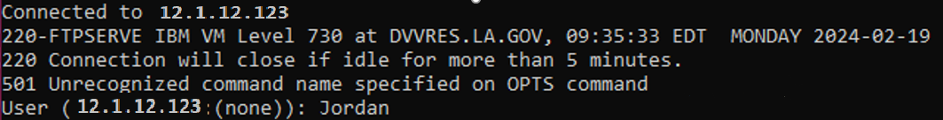
   2. password  
      xxxxxxx  
      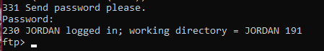
3. Change the working directory on your z/VM host to the minidisk where you want to load the files (note that there is a period between the user ID and minidisk address):
   1. cd zVMdirectorypath  
      cd JORDAN.191  
      
4. Set the Local Directory to the Windows Desktop folder location containing the files you intend to FTP or the destination folder for the files you’re FTPing from zVM.
   1. lcd desktopfolderpath  
      lcd C:\Users\P00341017\Desktop\zPROTempBox  
      
5. Set the file transfer mode to binary and the record format and length to fixed 1028:
   1. binary  
      binary  
      
6. Set the file transfer size to 1028 bytes. (Logical Record Length, AKA Lrecl)
   1. quote site fixrec recordlength  
      quote site fixrec 1028  
      
7. Put the installation files on the z/VM minidisk:
   1. mput file  
      mput *.PROD5*  
      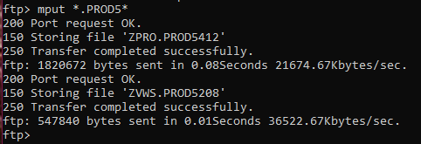
   2. All of the files in the directory that contain, “.PROD5”will now start to transfer. This could take some time, depending on the speed of your connection. For video walkthrough see, “zVM 7.3 FTP” within Reference Materials>Examples>FTP.

*Return to Step2*